 



Database Programming with SQL 18-1: Database Transactions Practice Activities

# Objectives

* Define the COMMIT, ROLLBACK, and SAVEPOINT statements as they relate to data transactions
* List three advantages of COMMIT, ROLLBACK, and SAVEPOINT statements
* Explain why it is important, from a business perspective, to be able to control the flow of transaction processing

# Vocabulary

Identify the vocabulary word for each definition below

|  |  |
| --- | --- |
| **ROLLBACK** | Ends the current transaction making all pending data changes permanent |
| **ROLLBACK** | Enables the user to discard changes made to the database |
| **SAVEPOINT** | Creates a marker in a transaction, which divides the transaction into smaller pieces |
| Read consistency | guarantees a consistent view of the data by all users at all times |
| **Lock** | Mechanisms that prevent destructive interaction between transactions accessing the same resource that can be granted to the user |
| **Transaction** | a collection of DML statements that form a logical unit of work |

# Try It / Solve It

1. Define the COMMIT, ROLLBACK, and SAVEPOINT statements as they relate to data transactions.

COMMIT, ROLLBACK и SAVEPOINT известны как TCL (язык управления транзакциями).

· COMMIT - сделать все ожидающие изменения постоянными.

· ROLLBACK - отменить сделанные изменения. Автоматический откат произойдет в случае сбоя системы для защиты целостности данных.

· SAVEPOINT - маркер для разделения транзакции на более мелкие части, возможен ROLLBACK на SAVEPOINT. SAVEPOINT не является объектом схемы, и на него нельзя ссылаться в словаре данных, он теряется после фиксации или отката (транзакция завершена).

RANSACTION-

· Starts with:

o DML (INSERT UPDATE DELETE MERGE)

· And ends with:

o COMMIT,

o Exit normally (implicit commit),

o ROLLBACK,

o DDL [CREATE DROP ALTER RENAME TRUNCATE]

o DCL [GRANT OR REVOKE].

1. What data will be committed after the following statements are issued?

INSERT INTO R values (5, 6);

SAVEPOINT my_savepoint_1; INSERT INTO R values (7, 8);

SAVEPOINT my_savepoint_2; INSERT INTO R values (9, 10);

ROLLBACK TO my_savepoint_1; INSERT INTO R values (11, 12); COMMIT;

Останутся записи (5,6) и (11,12)

1. Construct a SQL statement for the DJs on Demand D_SONGS table that deletes the song “All These Years,” inserts a new Country song called ‘Happy Birthday Sunshine’ by “The Sunsets” with a duration of 4 min and an ID = 60. Make sure that all data can be recovered before any changes to the table are made.

DELETE FROM d_songs

WHERE title = 'All These Years';

SELECT * FROM d_songs;

INSERT INTO d_songs (id, title, duration, artist, type_code)

VALUES (60, 'Happy Birthday Sunshine', '4 min', 'The Sunsets', 1);

COMMIT;

SELECT * FROM d_songs

WHERE title = 'All These Years';

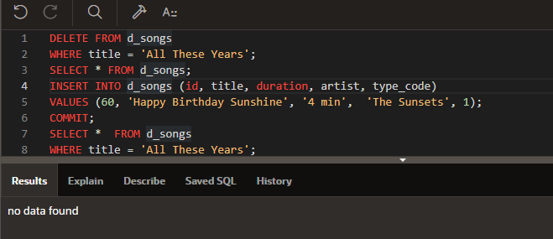

1. Write an SQL statement that will issue an automatic commit.

DELETE FROM d_songs

WHERE title = 'All These Years';

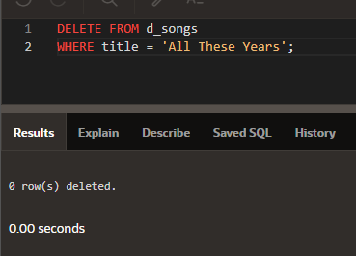

1. Give two examples of businesses other than banks that rely on transaction control processes. Describe why each business needs transaction processing control.

Любая проверка транспортного средства. Если одно из проверяемого неисправно, то будет отказано в заступленни на рейс

Или например любой процесс производства автомобиля, если не выполнить все действия в правильном порядке, то машина не получится.

Copyright © 2020, Oracle and/or its affiliates. All rights reserved. Oracle and Java are registered trademarks of Oracle and/or its affiliates. Other names may be trademarks of their respective owners.